Latin Quarter, October 2014
Dear Sisters and Associates,
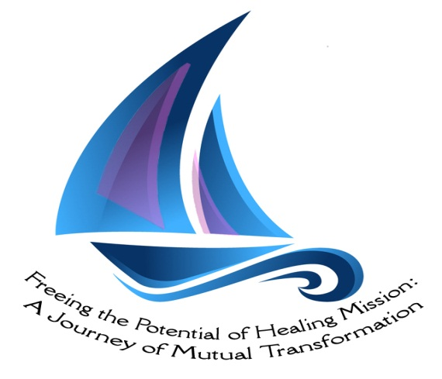
In tune with the theme of our next chapter: "Freeing the potential of Healing mission: a journey of mutual transformation", it is a pleasure to share with you some stories of our life in mission; stories of mutual transformation in Sector Latin America. We share also a reflection on the current outbreak of Ebola.

Golden Jubilee of Marielena Ridad - September 13, 2014
Undoubtedly today is a Day of many emotions. A day of celebration and reflection; a day of prayer and gratitude; a day to reflect on learning and the challenges.
If I were a poet, I would say that TODAY IS A SONG TO LIFE because life is that. It is history, it is time and space. Life is a situation, is an impact, is an imprint that you receive from life.
God has an unusual way to prepare us for his mission ... that has been my experience with him. I was born into a family that gave me a foundation for the future ... I had a father who marked my life with his conviction that work is what gives value to human beings. He infused in all his children a strong and deep sense of justice. My mother and her mother - my grandmother- with their deep religiosity, took care of not only teaching us religious practices like prayer every evening and going Mass every Sunday, but also explained to us what it means to be a good Christian ... What it means to serve without expecting any reward. their imprints and values were complementary. And this way of seeing life has been changing, clarifying and deepening along my journey as a Medical Mission Sister.
When I came here to Venezuela, especially to “Barrio Simon Bolivar” I resized my religious life. In this neighborhood, my neighborhood, I have learned many things. Many people have been my teachers. Many men and women have taught me so much, no only with words but with their testimony of life. With them I understood the gospel about the widow's mite ... what does it mean to share even what is needed for survival ... as the saying ... where two people can eat three or even four can eat. I learned to trust in God fully. In the morning when people asked me ... where are you going? My answer was: to seek God!
I learned to fight for what is ours, I learned that the blows that we receive as poor have cause, face, name and even lastname. I learned that when we said in the Prayer of Our Father that His Kingdom come to us, it means also to fight so we, the poor, have a more human life. I learned the meaning of the song that says "our faith cannot rest until we banish from our continent; hunger, torture, misery and injustice ... Because it is the mandate of love".
I celebrated 50 years. They have been 50 years!!. During recent days I have been thinking not so much in this beautiful celebration that many people: friends, my Sisters and Associates of the Society have prepared to me, but thinking and wondering where do I'm going today? I realized that I have not changed my option. I still vibrate with the passion of building the kingdom of God in the here and now.
I am still looking for ways of liberation, I am still committed for a more human and dign life and for a more just and fraternal world.
In this journey, there is always someone who asks me: Until when are you going to be in this fight, Marielena? My answer has been always: until death separates us, until we see victory.
Marielena Ridad, MMS.
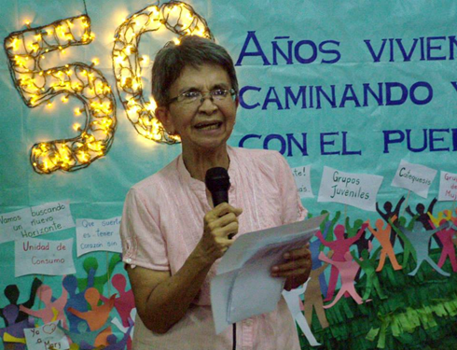

Keep your eyes open … your ears listening, attentive and sensitive
A brief reflection on our Venezuelan reality
There is a saying in Venezuela that goes something like this … “keep your eyes open … your ears listening, attentive and sensitive”. Everything that the press offers, TV or radio, we need to decipher what is the real message. And even go beyond … the cause, what is behind … So this article is an attempt to give some of the reasons behind what is happening in Venezuela these days.
Everyday news brings how the population is doing with regard to the cost of living: inflation rate is much more than expected, there is scarcity of basic products, corruption is rampant and contraband is not controlled: (witnessing how basic products are illegally exported to the neighboring country of Colombia) As a result, the ordinary family laments and criticizes the government. Beyond the government’s responsibility, it has to be mentioned that Venezuela is also affected by what happens worldwide. 2008 financial crisis has had its effects on the Venezuelan economy. The price of oil went as low as 35 $ a barrel from a high of 100 $.
Venezuela imports practically everything that the population consumes. Agro-industry has not been developed in the country. It is only when the late President Chavez entered into the political arena that agriculture received financial investment. Added to this is the “cultural” element present among many that would always prefer what is imported, what comes from abroad to what is produced in the country. Plus the fact that what is “public” is inferior to what is “private”. It is no wonder that up to today Venezuela consumes much more than what is in the country, imported products as well as what is produced locally. There is not enough production of basic products that would satisfy the population’s needs. Indeed the problem is complex and complicated, beyond putting the entire blame on the government.
On October 1st, of this year, the youngest (ROBERT SERRA, at the age of 27) member of the National Assembly was assassinated. The tragedy was headlines. Many voices were raised: different causes were put on the table. Those who oppose the government putting an accusing finger on those whose responsibility is to maintain law and order. For those who knew the assembly member’s positive contribution at the National Assembly, the motive for the assassination was clear: it was an act of terrorism … to put fear among the youth, to discourage base organizations, to conclude that in Venezuela, there is NO law and order. What people in the streets comment has some truth, it was NOT done by common delinquents. The purpose was to create an environment of “lawlessness and chaos” a perfect excuse to invite foreign intervention.
In the midst of many and complex problems in the country, the National Conference of Bishops has not emitted something that would enlighten the public in general in an effort to make sense of what is happening in the country. And even sad to see that every now and then a Bishop or a local parish priest would make broad statements about “communism” creeping in the Venezuelan society. It is an indication of the formation that our local clergy has received. IT is no wonder that among members of Basic Christian Communities, there is hesitation, almost a fear that it is treading on unknown grounds any reflection about political commitment of a Christian.
We (MMS) live with these uncertainties: the complexities of the economic situation of the country, the problem that has been rated number one in recent statistics, a polarized society that at times borders on extremes threatening an acceptable community living …MMS, today, we are challenged ever more to be alert, to be listening, to delve into the causes of what is happening. Nothing can be taken for granted. We are called to accompany people with whom we work, to offer whatever what would help in understanding our reality. We have accepted the challenge!

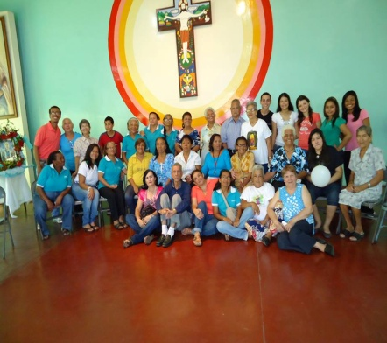
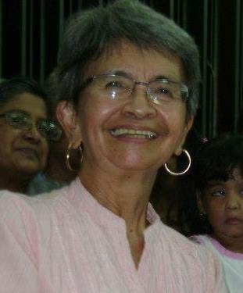
Marielena Ridad, MMS

Empowering youth

From Venezuela, I want to share with all of you a little of the flavor of our Project of empowering youth, which intend to contribute to reduce Violence in our country. The idea is to have a leadership course for youth where they can be prepared to be “leaders for peace” in our barrios. This initiative is supported by the Dioceses of Essen in Germany and Vrienden, and we started eleven months ago.

Violence has many faces; one of which is the violence in the family. Many of the participants in this workshop are victims of it. The workshops helped them not only to acquire some tools on how to handle such a situation and provide some help to their own families but also to help other families, sharing their testimonies and reflections.

With these activities, the participants are accompanied in working on their own inner violence, encouraging their commitment to promote peace in their community ... Another kind of violence we want to address is the violence in schools. Our schools and colleges are full of drugs and weapons... Students, who use drugs and weapons take a lot of space in our schools. We can see the walls of the institutions most often dirty and written with vulgar phrases or words. There is also a high rate of indifference and indiscipline. Some young boys are leaders but they draw many to do bad things.

The course has many workshops and activities…. This take place in 3 places,

- One part in Barquisimeto, at the youth center, in our Jesuit´s parish.
- A second part of the workshops and activities take place out of town, in a rural area.
- The Third part is held in different houses that we rent during weekends, especially for longer workshops.

At this moment all the participants are from Barquisimeto, but come from different neighborhoods or what we call sectors... From the 50 young people who have registered when the project started, 38 of them stayed and have been very loyal and committed. Twelve participants could not continue for different personal reasons.

In December we are going to open the registration of a new group of youth who will be part of the Project for 2015. We shall register at least sixty participants because we know that it is very probable that some of them won’t be able to continue. The idea is that, after evaluating the results of this experience, we could hopefully start this Project in other cities. There are some people interested in developing the proposal.
At this time in Barquisimeto, we are two MMS involved in youth work, but I am the one responsible of carrying out the project. Sister Luz Marina Chirinos supports the project by sending some young people with whom she works with in Barrio 12 de October to participate. There are 2 MMS Associates who are helping in many ways. 3 young ones are working full time with me in the logistics for the program.

I have facilitated several workshops; facilitators are from Barquisimeto and other cities. Some of them belong to Religious Congregations, others Non-Governmental Organizations (NGOs) and other institutions and groups. Who facilitates depends on the subjects and content. Until now, we have a group of eighteen facilitators ... They are committed to support this Project.

Part of the program is to have a mission exposure…. These are the Goals and steps of the experiences of mission:

- To facilitate for the young people the experience of getting to know other realities, different from Barquisimeto, where they reside so they can commit to a dream for peace in the city where they come from, for the whole country and to the world .
- To provide spaces where they can put into practice all the knowledge they have acquired in workshops and other related activities.
- To have the opportunities to visit homes, organize daily activities for children and youth of the community where they are.
- To promote conversations related to violence and ways to address it, with the community where they carry out their mission exposure.
- To have an opportunity to live together in a place where they could participate in community activities: dish washing, cooking, cleaning the house, preparing prayer, etc.
- To have opportunity for formation during the time they are together.

We have short and long expectations of this project:

- We have short and long expectations of this project:

- That young leaders be aware of the reality around them thus commit themselves to opt for life and peace in our communities.
- That they may become critical, sensitive and contribute to reduce levels of violence in their own homes, schools where they are enrolled and in the neighborhood where they are.
- That NGO groups, Religious Congregations, schools and families are encouraged and motivated to participate in this project to work with the youth.
- That we are able to form a team of committed facilitators to be involved in the project.
- To promote initiatives that will lead to peace and respect for life.
Long Term Expectations

- 159 young people trained with tools to promote a culture of peace in the city and in the country.
- Reduced violence, at least 50%.... While we dream of eliminating it.
- Spaces won for the enjoyment of children, youth, and families.
- Clean Schools, motivated and committed youth to their school and community.
- Successful experiences with the support and participation of many.
- A successful experience that can be duplicated in other cities.
- Individuals and local groups to financially support this project.

We have a lot of hope in this project, which started to emerge into something good and new, to protect life and to find peace. We are very grateful to all the people who are helping us, who are supporting this project. I will be sharing the second part, in the next Latin Quarter.
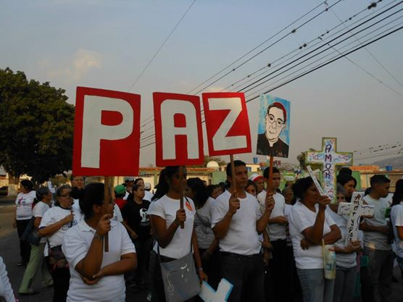
Maigualida Riera (Mai), MMS

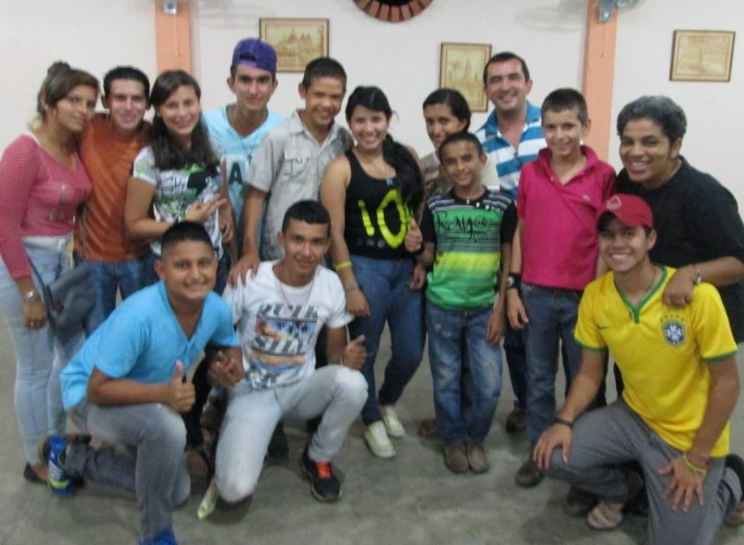

I took her out into the desert and talk to her heart "Hos 2:16
With this quote from the book of Hosea, I describe the experience in my new mission involvement in Arequipa. I am Norys Navas and arrived to Peru on January 6 this year, along with the Magi. I took a 18 hour bus ride from Lima to Arequipa. Looking through the window at dawn, I saw a vast desert, some houses made of mats and some dry mountains. I broke into tears and thought: "God is this where my sisters live? I have never imagined such a desolated road". Then I said: Lord, this is where you brought me. What can I do for you? Immediately I began to see some people working in their farms, some green also appeared. I calmed down and my heart began to feel at peace. I trusted in God who brought me to the desert, blooming with her presence and tenderness.
So, I arrived to Arequipa and was welcomed by Marisol, Patricia and Christianne who was visiting.
I visited COFARI (Family Community for comprehensive Rehabilitation) and I fell in love with the project and the children. I had never had close contact with children with severe cerebral palsy. At first I did not know what to do, what to say, how to help. It was hard.
Eventually, with songs and laughter; learning to feed them; painting and dancing with them; telling stories with mimic, I found myself being close to them. I realized that I can contribute with my gifts, my artistic skills and as a psycho-pedagogue.
I am currently responsible for Occupational Therapy and Sensory therapy. I do enjoy being with children and apply techniques that help them to learn how to do basic activities of daily life and strengthen their psychomotor and cognitive skills.
I feel part of the team in COFARI with Sister Pat and Mrs. Dina our principal. We have had difficult moments and funny too. We are now in a period of restructuring the institution and dreaming together for the future for the children, and the family that we are in COFARI.
There is plenty to do, to build and to walk together. I plan to stay for three years, to embrace this project, this culture, this country and its beautiful people.
Thanks to all my sisters who have trusted in me to give my best in this new involvement of our Healing mission. God bless you.
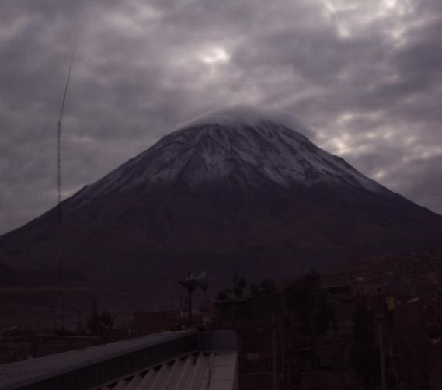
Norys Navas, MMS

My healing experience being Associate of the Medical Mission Sisters
"If you love, you want to give tirelessly, openly and generously." Anna Dengel.
Being Associate of MMS has led me over the years to feel healed as I'm helping others to heal, through my work with children with disabilities, youth pastoral and alternative therapies.
God has given me a very specific calling: To be a healing presence at the heart of a wounded world" and I try every day to be faithful to this commitment with all my life, giving myself with generosity, offering what I have, serving with my potential and limitations, just being a good Christian.
How can I not be grateful to God if he has been so good to me, if he has always put his eyes on me and entrusted part of his mission to this humble servant.
Today I embrace the charism of Jesus the Healer through my being Associate of MMS because I believe that every day, there is a need for healing for many people around me and there is much to heal also in my life.
Walking along with the Sisters and other partners, motivates me, fills me with joy, renews me every day, makes me dream and to feel alive and hopeful.
I want to thank Medical Mission Sisters for being the instrument that God has used for me to be part of this beautiful mission: To be a healing presence and, at the same time, being healed myself, together with other men and women. Thanks God for calling me to be an Associate from what I am and have; for making me part of those who put their bit of sand to build a different and better world. 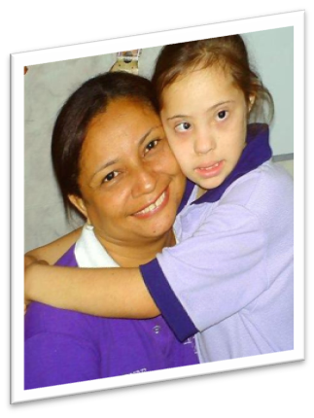 Yira Infante, MMS Associate.
Sharing the experience of finding my way with MMS

Telling you how I came to know the Medical Mission Sisters, and why I am living this experience among them today, is also telling you about how God works when he calls.

Since my teens I have felt that my vocation goes beyond living in this world settled down with what it offers; I always felt the need to help others, to care about the problems of people who crossed my path. In my experience, I have always interacted with people who were part of religious Congregations, or were close to them, like my parents, who also educated us with Christian values. I received my catechetical formation with Salesian seminarians. My sisters studied at a school run by the FMA. One of them had a two year experience with them but it was not so good. My mom worked for the Sisters of St. Anne and my dad worked at the Salesian Seminary. As you can see, we were always surrounded by these experiences. In spite of that, I never thought seriously about entering a religious congregation. I dedicated myself to study and work and did not pay attention to this “first call”.

By the time I finished my studies in Higher Education, I felt that I was lacking of something and decided to participate in the activities of the Parish. I joined the group of catechists and of Liturgy as reader and psalmist; I also was part of a youth group of Salesian spirituality who used to sing at the Masses.

At that point, I still felt there was something missing and I talked to a Salesian friend, a former religious, who advised me to look for someone who could guide me and help me on this path of discernment. She spoke of a Sister of the Missionaries of Jesus Christ. At the Catechesis I had already met the Sisters of the Sacred Hearts of Jesus and Mary, who were also involved in parish activities.

I contacted Sister Mariangeles - Misionary of the Heart of Jesus-, who guided me and encouraged me to live a deeper experience with the Sisters who I had met in the Parish. I made a Vocational retreat with them and after that I was invited to make the Ignatian Spiritual Exercises, which were to take place in Mérida State in September.

By that time I had already applied for a permit in my work, for studies. This time served me to successfully finish my studies and to clarify better my thoughts. I dedicated that time to discern the call that was there for a long time resonating in me, and I had not paid attention to, due to the many activities I had.

I attended the retreat in Merida, where I was supposed to be accompanied by one of the Sisters of the Sacred Hearts of Jesus and Mary. However, when I arrived to the retreat venue, I learned that I had been assigned to be accompanied by Sister Maigualida (Mai-MMS). At that moment I came to know that there was a congregation called Medical Mission Sisters, whose charism was healing.

Sharing with Sister Mai about the process that I was already in, she invited me to visit the community in Caracas to get to know them a little more. She also encouraged me to continue exploring my vocation with the Sisters of the Sacred Hearts of Jesus and Mary, who had proposed me to have a one week mission experience in Caracas, taking advantage of the permit that I already had asked from my work.

In fact, I had a week of mission experience with the Sisters of Reparation and also visited MMS in their house of Caracas. I could compare how the sharing and the relationship were between the sisters in each community. Then, Sister Maigualida invited me to participate in the Easter camp in Lara State in a little town called Los Potreritos. That experience filled me with the satisfaction of being able to go where others cannot reach and of being heartily welcome by people who just met me and made me feel at home. I felt the joy of sharing that experience with others who also risk building a better world.

Those experiences encouraged me to make the decision to risk and learn more about this congregation of which I had never heard of and I barely knew. I shared my decision with my family, with Sister Mariangeles who was accompanying my journey of discernment, and of course, with Sister Maigualida, who explained to me how the process was and what had to be done in order to start my experience in her community. This process began in May 2013, and during year that I have been able to know them more. I have realized that there are various ways to serve our brothers and sisters. I learned that we can be builders of the Kingdom of God with the gifts received from God and multiply them as the faithful servant did.

What has helped me to reaffirm my decision to join this group of women is to know that I can serve my brothers and sisters from what I am; that action is also prayer and that I don’t have to get away from the world’s reality or be enclosed in four walls to get closer to Jesus. He is present in each of the faces of our people: children living with disabilities that are rejected and discriminated by a demanding and dehumanized society, immigrants coming to our country in search of a better future, those who live their daily lives without realizing that Jesus is with them and that they too can make a better world. I learned that belonging to a congregation with a healing charism, means also learning to heal our own wounds and assist others to heal theirs.

This has been my experience and the path I have chosen; living in a broken world that needs people who are willing to accompany its healing process.

In this sense, choosing religious life means finding a group of people who journey together and put their gifts and vocation at the service of God, according to the needs of our Church; it is to walk together in the same direction.

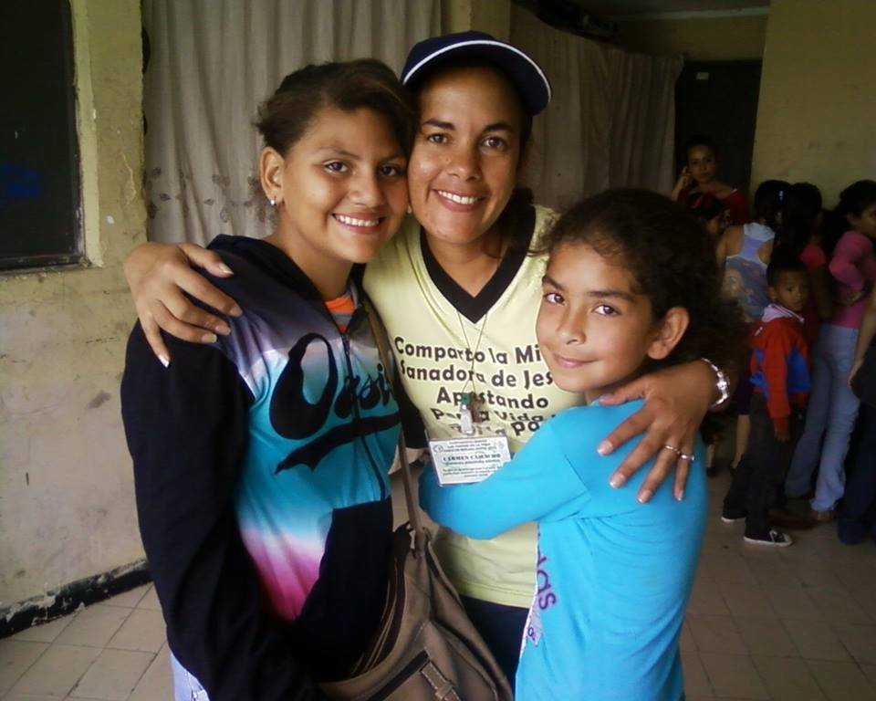 Carmen Camacho, First year MMS Candidate

Love in the time of Ebola
The Ebola virus has caused, since March 2014, an outbreak in West Africa (especially in Liberia, Guinea and Sierra Leone) which is the largest in the history of this disease and has been declared by the World Health Organization (WHO) as "the most severe health emergency seen in modern times" and by the Security Council of the United Nations (UN) as "a threat to international peace and security." It is certainly a tragedy. At the time of this writing, according to official figures, cases exceed ten thousand and the number of deaths is more than five thousand.
The outbreak affected especially communities in extreme poverty in these countries and added to the lack of public services, overcrowding, a very precarious health system, the malnutrition that gnaws millions of people and other serious infections that swarm there, like tuberculosis, malaria and typhoid. In other living conditions and access to adequate care from the onset of symptoms, mortality of Ebola probably would not had been as high.
What happened this time? Why this outbreak is on the front page of the mass media in the world, and nearly 20 outbreaks of the virus since 1976 did not call the international attention? Why organizations so committed to the fight against the disease, like Doctors Without Borders, tried unsuccessfully to wake up international awareness before?
It happened that this time the virus came from the poorest corners of Africa and migrated to other continents. This triggered an outbreak more dangerous than the virus itself: the outbreak of paranoia, fear that “what comes or who comes from Africa" would potentially infect us. So, public attention is facing these countries with a mixture of panic, misinformation and compassion.
It happened that now is urgent to find a cure, and then, research on possible vaccines finally found enough international funds.
It happened that when the first cases in Spain and the United States occurred, their stories captured the media. As the drama of Teresa Romero and her puppy Excalibur, Thomas Eric Duncan, nurse Nina Pham and others, crinkled our hearts, thousands of names and stories of victims in Africa remained anonymous.
It happens that poverty kills, cutting lives and dreams, removing chances of receiving the necessary care and even the possibility of dying with dignity. Ebola reveals once again the profound inequality in which we live, and that is more dangerous to mankind than any emerging virus.
When faced with life threatening situations which arouse our fear to be damaged and die, arises in every human being the better or the worse. In this case, in one hand, discrimination, indifference, selfishness and despise have emerged. But in the other hand, solidarity, compassion and boundless generosity arose. There are countless testimonies of religious missionaries / as, health personnel, members of various organizations, community leaders, etc., who have closely accompanied the affected populations. Many of them are part of the victims.
Ebola reminds us of our great vulnerability as human beings before microscopic creatures that can even end our lives. It is a challenge to our healthcare systems worldwide, but it is also a challenge to our social fabric; our political system and values; our faith. It is a challenge to our ability to see reality and to feel outrage; to speak out against injustice and inequality; to lift our voice and denounce the misery in which millions of people live. It is an invitation to transform our individual helplessness and frustration in collective actions.
The Ebola time reminds us of the call of God to comfort our people. The appeal as human beings, as Christians, to let the pain of others affects us; to get involved, to be a voice of encouragement in the midst of chaos, to spread hope and trigger an epidemic of LOVE in poor suburbs of the forgotten corners of our planet.

María Fernanda Ramirez (Mafe), MMS
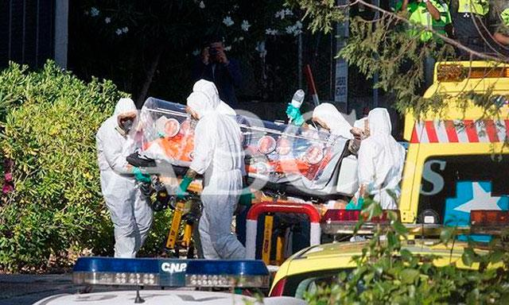

Important Happenings in MMS Life during 2014
Celebrations
- On March 19th, Ruthdely Peñaloza began her Aspirancy in Venezuela
- On May 31st, Carmen Camacho began her Candidacy in Venezuela
- Last August 2nd, Our Jorge Reyes made her first commitment as MMS Associate in Callao.
- On August 15th, Marielena Ridad celebrated her Golden Jubilee as MMS. There was a celebration with MMS during our meeting in Lima and then, with MMS and friends, on September 14^{th,} in Maracaibo.
Comings and goings
- From April to July, Gisela Reich went to Germany for her furlough
- From July 9th to August 12th Maria Fernanda Ramirez (Mafe) had a mission exposure in Jakarta and attended the GNM (Gathering of Newer Members) in Bandungan – Indonesia
- On October 8th Birgit Weiler went to Frankfurt because she was invited to teach at the Johann Wolfgang Goethe University She will be there until the end of the year.
- From October 15th to 25th Emma Panizales and Maigualida Riera (Mai) attended the expanded GA in Philadelphia. Emma is going to stay for the GA there.
Meetings
- From August 14th to 29th our all members meeting of Sector Latin America was held in Lima.
- Our 43rd Sector Assembly was held also in Lima from August 31st to September 3^{rd.}
Beginnings
- On January 6th Norys Navas from Venezuela came to join our mission in Arequipa for three years.
- Next month Tomasa Martinez is going for mission experience to Venezuela for one year.
- Last September, Teresa Murphy came from The US to our Community in Arequipa as a volunteer. She will be there for four months and then she is going to our Communities in Barquisimeto for six months.

Thanks to God for her faithfulness and unconditional love
Maria Fernanda Ramirez (editor) and all MMS and Associates in Sector Latin America.

